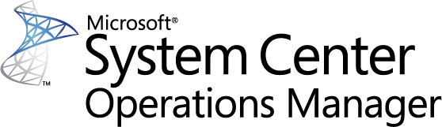

Guide for Visual Studio Team Foundation Server 2015 Management Pack for System Center
Microsoft Corporation
Published: December 2015
If you have an idea or suggestion about this management pack, the Operations Manager team encourages you to share it at the SCOM Feedback site.

Copyright
Information in this document, including URL and other Internet Web site references, is subject to change without notice. Unless otherwise noted, the companies, organizations, products, domain names, e-mail addresses, logos, people, places, and events depicted in examples herein are fictitious. No association with any real company, organization, product, domain name, e-mail address, logo, person, place, or event is intended or should be inferred. Complying with all applicable copyright laws is the responsibility of the user. Without limiting the rights under copyright, no part of this document may be reproduced, stored in or introduced into a retrieval system, or transmitted in any form or by any means (electronic, mechanical, photocopying, recording, or otherwise), or for any purpose, without the express written permission of Microsoft Corporation.
Microsoft may have patents, patent applications, trademarks, copyrights, or other intellectual property rights covering subject matter in this document. Except as expressly provided in any written license agreement from Microsoft, the furnishing of this document does not give you any license to these patents, trademarks, copyrights, or other intellectual property.
© 2015 Microsoft Corporation. All rights reserved.
Microsoft, Windows, Windows Server, and Active Directory are trademarks of the Microsoft group of companies. All other trademarks are property of their respective owners.

Contents
Guide for Visual Studio Team Foundation Server 2015 Management Pack for System Center 4
Management Pack Purpose 6
Discovery Process 6
Objects the Management Pack Discovers 6
How Health Rolls Up 9
Health Model 9
Monitors 12
Viewing Information in the Operations Manager Console 12
Diagram Views 13
Console Tasks 17
Diagnostics and Recoveries 17
Reports 17
Customizing the Management Pack for your Monitoring Needs 22
Create a New Management Pack for Customizations 22
Appendix A – Installation on Systems Center Operations Manager 24
Pre-Requisites 24
Steps to Remove Any Previously Installed Versions of the Visual Studio Team Foundation Server 2015 Management Pack for System Center 24
Steps to Install the Management Pack 25
Installing the Visual Studio Team Foundation Server 2015 Management Pack for System Center. 29
Associate the “Run As Account” to the “TFS 2015 User Profile” 30
Allow the Application Tier Servers Permissions in Operations Manager. 37
Non-Default Port Configuration and SSL Only Bindings 38
View of the Visual Studio Team Foundation Server 2015 Management Pack for System Center Objects in the Operator Console 42
Appendix B - Known Issues and Troubleshooting 45
Troubleshooting Incomplete Discovery 45
Troubleshooting Unexpected Health Status 47

Guide for Visual Studio Team Foundation Server 2015 Management Pack for System Center
This guide was written based on version 14.0.24807.0 of the Management Pack for Visual Studio Team Foundation Server 2015.
Guide History

Release Date | Changes
November 2015 (14.0.24622.0) | Original release of this guide.
December 2015 (14.0.24807.0) | Correct Problem with monitoring Team Foundation Server instances that use SSL.

Supported Configurations
This management pack requires System Center Operations Manager 2012 R2 or greater. A dedicated Operations Manager management group is not required.
This management pack has a dependency on and is meant to be used in conjunction with Microsoft Visual Studio Team Foundation Server 2015. The following table details the supported configurations for the Visual Studio Team Foundation Server 2015 Management Pack for System Center:

Configuration | Support
Team Foundation Server 2015 | Yes.
Non-default ports and HTTPS | Yes
Virtual directories | Yes
Cloned/clustered Application Tiers in the same domain | Yes
Agentless Monitoring | Not supported

Management Pack Scope
The Visual Studio Team Foundation Server 2015 Management Pack for System Center provides both proactive and reactive monitoring of Microsoft Team Foundation Server (TFS) 2015. It monitors TFS components such as application tier server instances, team project collections, build servers, and proxy servers.
The monitoring provided by this management pack includes availability and configuration monitoring, performance data collection, and default thresholds. You can integrate the monitoring of TFS components into your service-oriented monitoring scenarios.
Please note that some screenshots in this guide are borrowed from the guides for management packs targeting earlier versions of TFS.
Prerequisites
As a best practice, you should import the Windows Server Management Pack for the operating system you are using. The Windows Server Management Packs monitor aspects of the operating system that influence the performance of computers running SQL Server, such as disk capacity, disk performance, memory utilization, network adapter utilization, and processor performance. We also recommend the SQL Server and Internet Information Services (IIS) Management Packs. The Visual Studio Team Foundation Server 2015 Management Pack for System Center does not require any additional Management Packs that are not part of the standard Systems Center Operations Manager installation.
Due to the security model that Team Foundation Server 2015 uses, the monitoring account will need to be a member of the [TEAM FOUNDATION]\Team Foundation Administrators group. This enables the management pack to discover and monitor new Team Project Collections as they are added to the configuration without requiring additional incremental security configuration. The detailed setup instructions located in Appendix A of this document outline the creation of the required monitoring account as well as required security privileges.
Mandatory Configuration
For general information about importing a management pack, see How to Import a Management Pack in Operations Manager.
By default the .MSI installer will place the management pack files in the “%ProgramFiles(x86)%\System Center Management Packs\Team Foundation Server 2015 MP” directory unless the install location is modified during the install.
To start monitoring, import the TeamFoundationServer2015.mpb file into System Center Operations Manager. It is highly recommended you follow the detailed installation instructions in: Appendix A – Installation on Systems Center Operations Manager. The installation requires a number of setup steps to properly configure the management pack to discovery the TFS installation.
Files in this Management Pack
The following table describes the files included in this management pack.
File | Display name | Description
TeamFoundationServer2015.mpb | Visual Studio Team Foundation Server 2015 Management Pack for System Center Bundle | Contains the object types, discoveries, and monitoring for Team Foundation Server 2015.
EULA.RTF | End User License Agreement | The license for the Visual Studio Team Foundation Server 2015 Management Pack for Systems Center.

Management Pack Purpose
You can use the Team Foundation Server 2015 Management Pack to monitor components of Team Foundation Server 2015 system, including application tier servers, team project collections, build servers, and proxy servers. Once installed the management pack will discover the Team Foundation Server 2015 installations that are installed on SCOM monitored servers. For more information about object discovery, see the Object Discoveries in Operations Manager topic in the Operations Manager help documentation.

Discovery Process
Once the installation has been successfully performed and Team Foundation Server MP is loaded, the discovery process can start. At the end of this process, which can take up to 15 minutes, various Team Foundation Server objects are created and their properties are set with discovered values. The objects discovered will vary for different Team Foundation Server deployments based on the deployed configuration. Along with the objects, the relationships between these objects are also established.

Objects the Management Pack Discovers
You can use the Visual Studio Team Foundation Server 2015 Management Pack for System Center to monitor components of a Team Foundation Server 2015 installation. The management pack is configured to do automatic discovery of each Team Foundation Server 2015 installation by performing queries against the Team Foundation Server 2015 configuration APIs. For more information about object discovery, see Object Discoveries in Operations Manager in the Operations Manager help guidance.
The Team Foundation Server 2015 Management Pack discovers the object types described in the following list.
Objects Discovered and Monitored
TeamFoundationServer2015.TFSInstallation
TeamFoundationServer2015.TFSApplicationTierServer
TeamFoundationServer2015.TFSAdministrationWebService
TeamFoundationServer2015.TFSAuthorizationWebService
TeamFoundationServer2015.TFSBuildWebService
TeamFoundationServer2015.TFSProjectCollection
TeamFoundationServer2015.TFSRegistrationWebService
TeamFoundationServer2015.TFSVersionControlWebService
TeamFoundationServer2015.TFSWarehouse
TeamFoundationServer2015.TFSWebAccess
TeamFoundationServer2015.TFSWorkItemTrackingWebService
TeamFoundationServer2015.TFSBuildAgent
TeamFoundationServer2015.TFSBuildController
TeamFoundationServer2015.TFSBuildServer
TeamFoundationServer2015.TFSProxy
TeamFoundationServer2015.TfsVsoAgent
TeamFoundationServer2015.TfsVsoAgentService
Objects Discovered Initially, but not Monitored
TeamFoundationServer2015.TfsApplicationTierServerCandidate
TeamFoundationServer2015.TfsBuildServerCandidate
TeamFoundationServer2015.TfsProxyCandidate
TeamFoundationServer2015.TfsVsoAgentCandidate
Relationships Discovered
TeamFoundationServer2015.TFSInstallationContainsATServer
TeamFoundationServer2015.TFSATServerHostsAdministrationWebService
TeamFoundationServer2015.TFSATServerHostsAuthorizationWebService
TeamFoundationServer2015.TFSATServerHostsBuildWebService
TeamFoundationServer2015.TFSATServerHostsRegistrationWebService
TeamFoundationServer2015.TFSATServerHostsVersionControlWebService
TeamFoundationServer2015.TFSATServerHostsWebAccess
TeamFoundationServer2015.TFSATServerHostsWorkItemTrackingWebService
TeamFoundationServer2015.TFSInstallationContainsProjectCollections
TeamFoundationServer2015.TFSInstallationContainsWarehouse
TeamFoundationServer2015.TFSBuildServerHostsBuildAgent
TeamFoundationServer2015.TFSBuildServerHostsBuildController
TeamFoundationServer2015.TFSInstallationContainsBuildServer
TeamFoundationServer2015.TFSProjectCollectionContainsBuildAgent
TeamFoundationServer2015.TFSProjectCollectionContainsBuildController
TeamFoundationServer2015.TfsInstallationContainsVsoAgent
TeamFoundationServer2015.TfsVsoAgentHostsVsoAgentService
TeamFoundationServer2015.TfsProxyReferencesProjectCollection
TeamFoundationServer2015.TfsProxyReferenceTfsInstallation

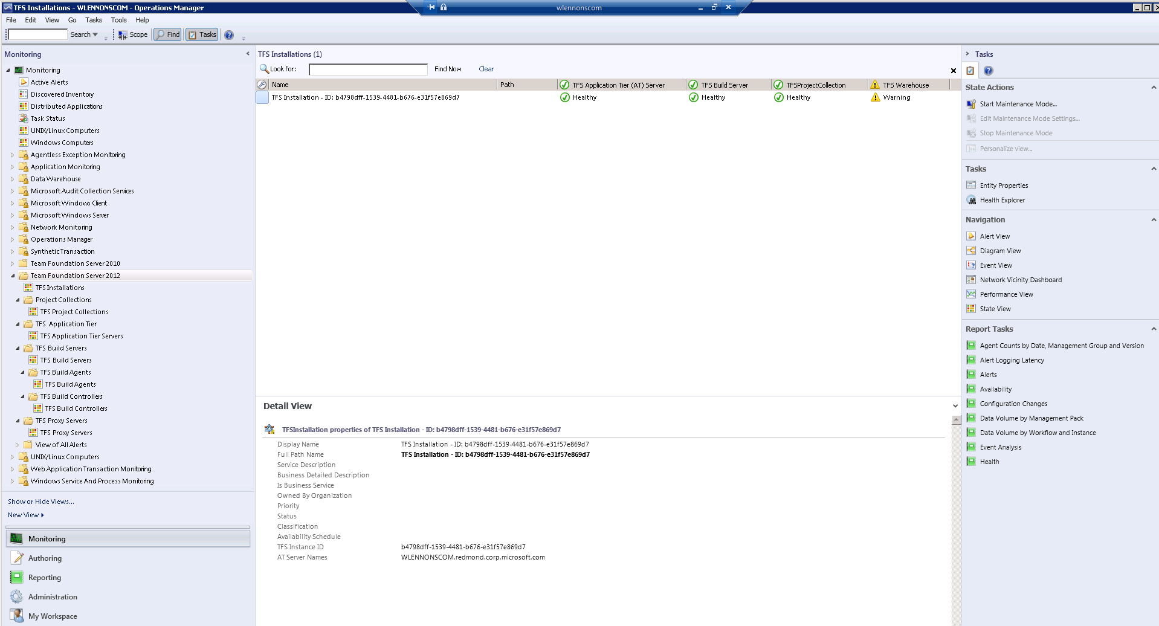
The following screen shot shows that a TFS installation has been discovered. This view will vary based on the specific local environment where the Visual Studio Team Foundation Server 2015 Management Pack for System Center is used.

Similarly, other Team Foundation Server objects that have been discovered can be navigated to in the left pane and browsed from the Operator Console.

How Health Rolls Up
The Visual Studio Team Foundation Server 2015 Management Pack for System Center categorizes the server components into a layered structure, where the health of one layer can depend on the health of the lower level.

Top Level
The top level of this model contains the TFS Installation object. If the components of the installation are not healthy, the installation is not healthy.

Second Level

The second level contains these components: | • Application Tier Servers  • Build Servers  • Team Project Collections  • Analysis Services (contains no lower-level components)  • Etc.  Note: The health of each of these components directly affects the health of the TFS Installation.

Health Model
Health Model is comprised of the dynamic view of the states of various Team Foundation Server objects. Note that the health states of the Team Foundation Server application tier, is a dependent function of the health of its sub-components. There is a dependency relationship in the health model as rollup of health states from the sub-components to the top level node happens.
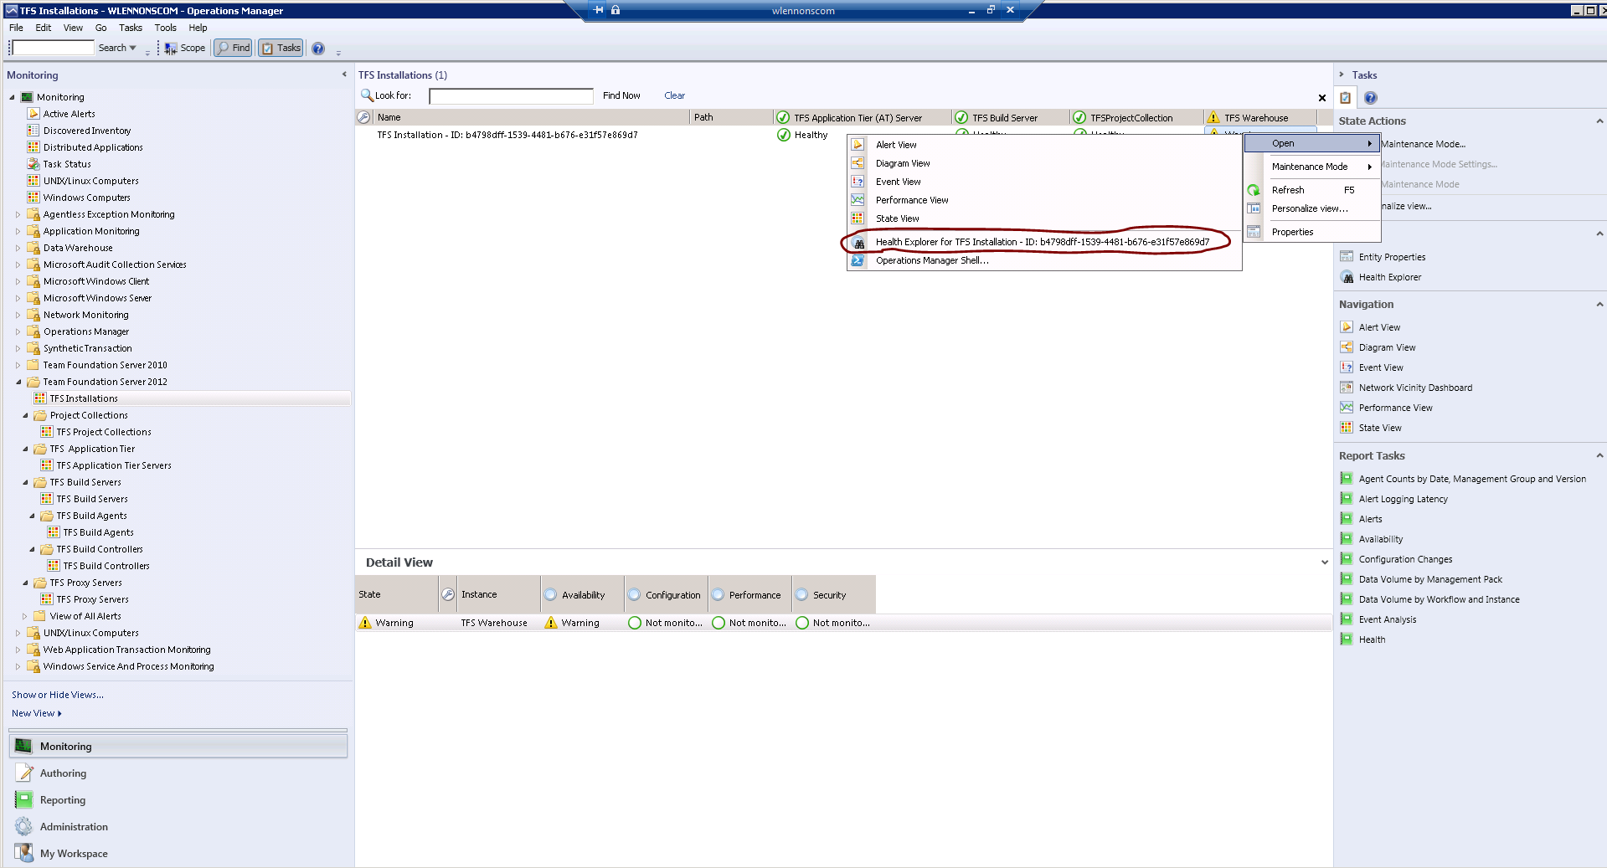
To view the health model of any entity, right click on the object in the “Details View” in the middle pane and click Open->Health Explorer for that specific object. Or just click on the Health Explorer in the Actions Pane on the right. The health explorer can be launched for the top level object as well as the objects lower in the hierarchy.

Figure: Health Model View

Once the Health Explorer is launched, its window pops up showing the state of the object and the various monitors of that object arranged in a tree view as shown below.
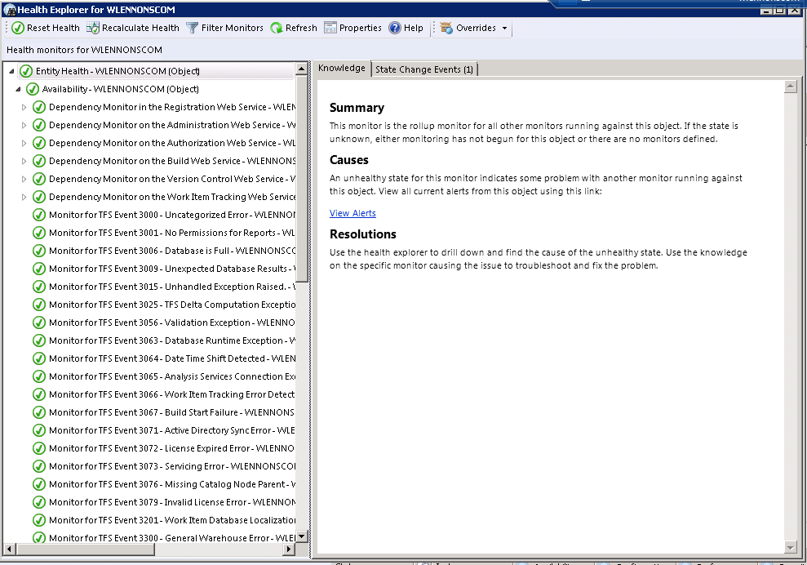
Figure: Health Explorer View
The following is another view of the Health Explorer for an object showing a few unhealthy states (red). Additionally, the possible causes and resolutions are listed on the “Knowledge” article on the right.
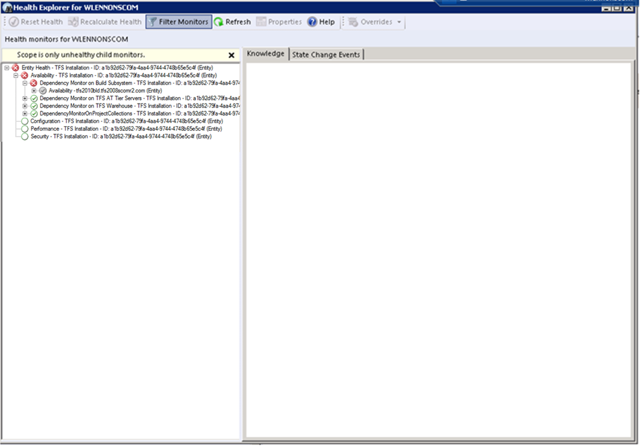
Figure: Health Explorer View with Critical Alerts
As mentioned, the health model is a reflection of the state of the object instance at that point in time and is constantly updated by the various monitors that run in the background. Incidentally, the health model also shows the containment relationships of the service model in the form of the ability to drill down into the contained objects health.

Monitors
Primarily the monitors are comprised of three types;
- Monitors that watch event log entries
- Script based Web Service and Component Monitors which query the various web services for proper response status
- Monitors for key Team Foundation Server 2015 system performance counters

Viewing Information in the Operations Manager Console
You can see a high-level view of object types in your Team Foundation Server 2015 deployment.
A view can contain a lengthy list of objects. To find a specific object or group of objects, you can use the Scope, Search, and Find buttons on the Operations Manager toolbar. For more information, see the How to Manage Monitoring Data Using Scope, Search, and Find topic in the Operations Manager help guidance.

Diagram Views
The relationship between the various objects in the Service Model for Team Foundation Server can also be viewed by using the Diagram View feature of the Operator Console.
The diagram view is accessed by right clicking the object in question and choosing the “Diagram View” menu option as shown below.
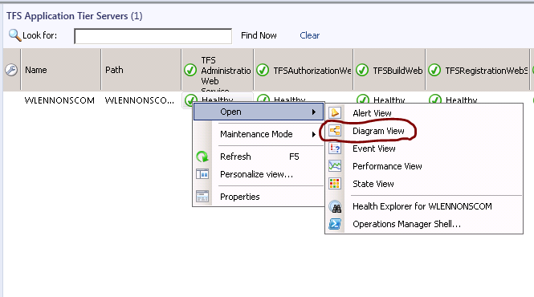
Figure: Opening the Diagram View
Once the basic view shows up, refresh the Diagram View pane and click on the + sign to drill down deeper if required. Sometimes the Diagram view surface is blank and may need to be refreshed.
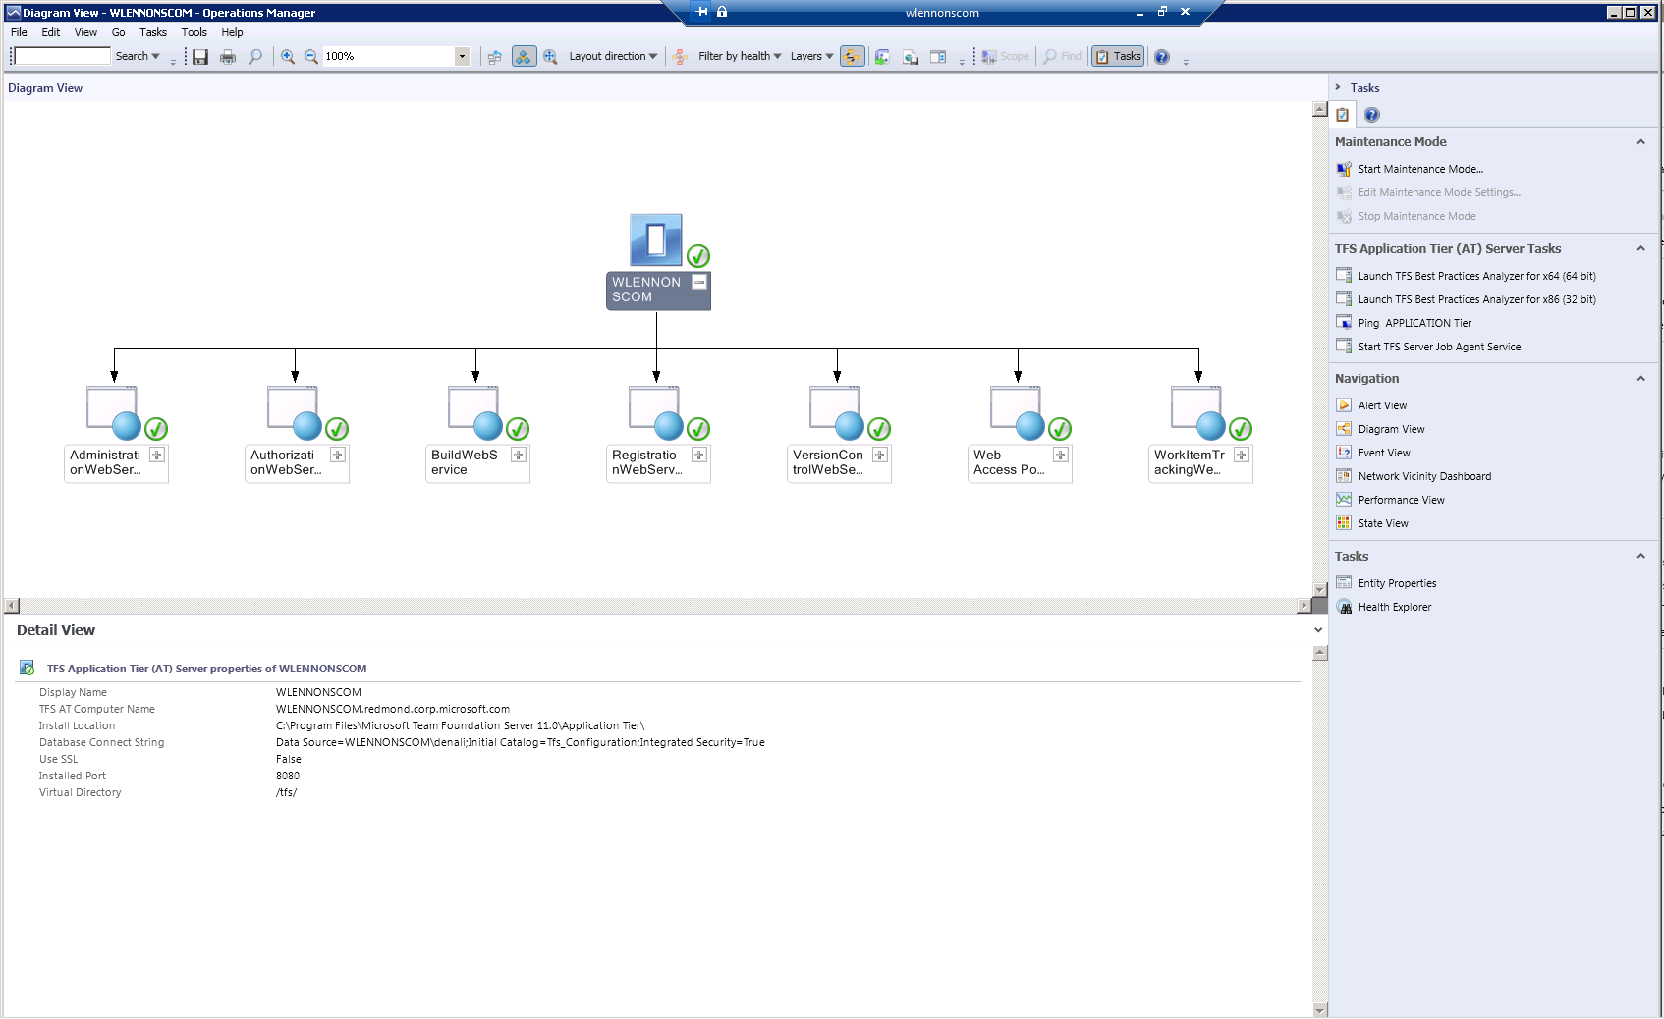
Figure: Diagram View after full drilled down

Alert Views
The following Alert Views are defined in the Operator Console.
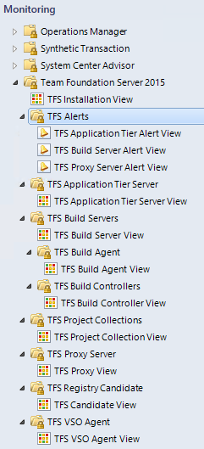
Figure: Alert View node on the Monitoring console.
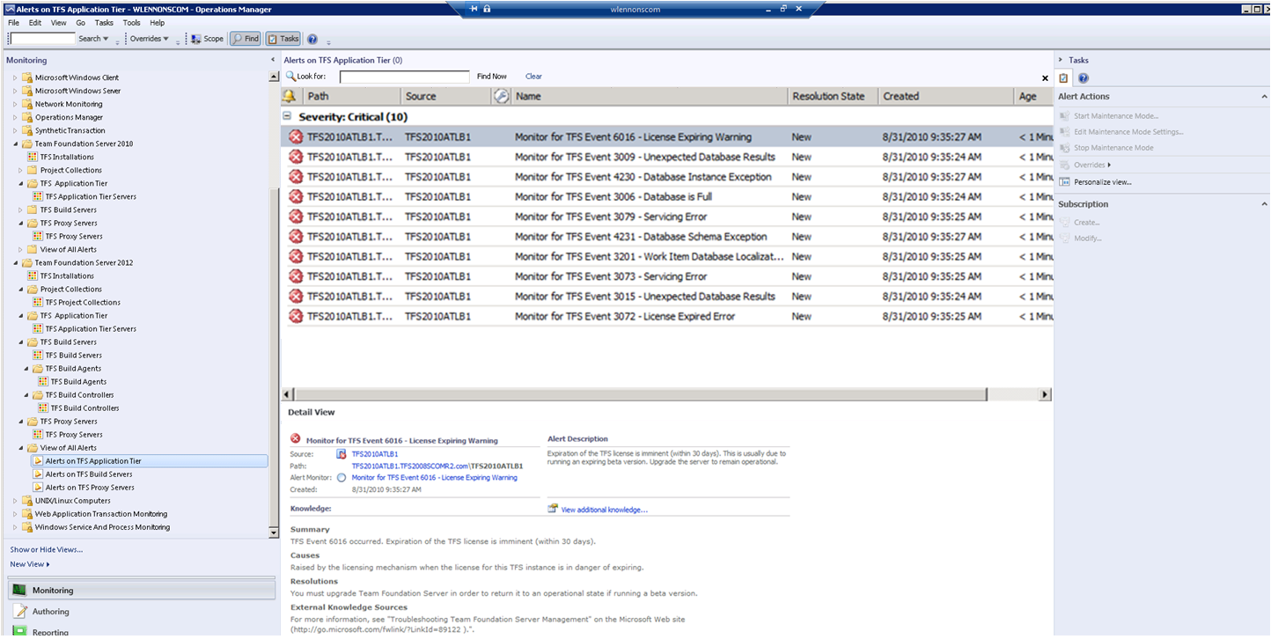
Figure: View of a few Alerts

Tasks
There are two types of tasks. Console tasks which execute on the Operator Console host and Agent tasks which execute remotely on the host where the OpsMgr Agents are installed. In case of Team Foundation Server, these will be on the hosts where the application tier or build server is detected. These tasks can be launched by clicking on the task.
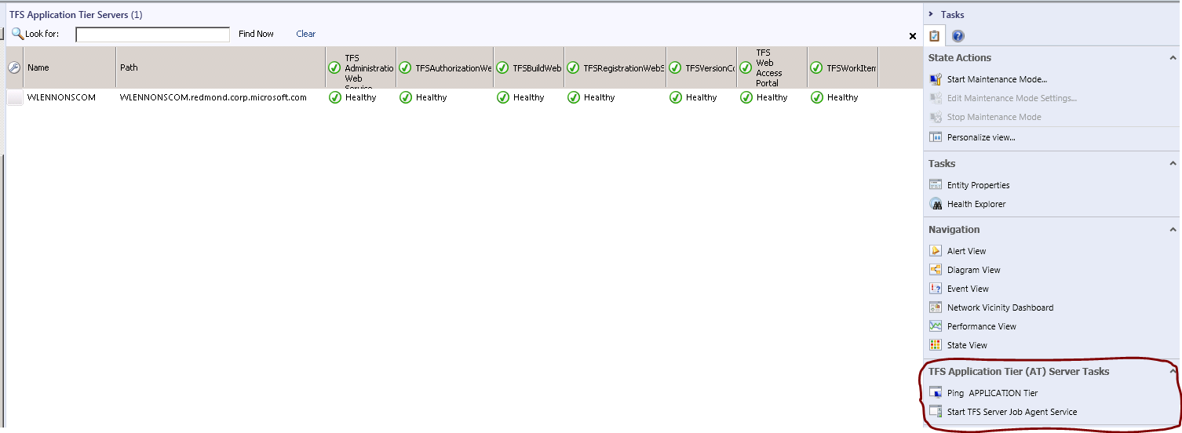
Figure: Launching Tasks

Console Tasks
- Ping Application Tier Machine: Ping the Application Tier machine and check if it is reachable.
- Ping Data Tier Machine: Ping the Data Tier machine and check if it is reachable.

The following is the output window when the task “Ping Application Tier” is launched.
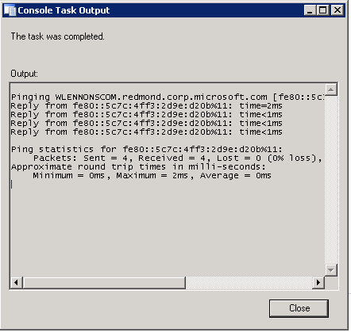
Figure: Output of Console Task “Ping Application Tier”

Diagnostics and Recoveries
There are a few diagnostic and recovery actions included. These are primarily for the “Team Foundation Server Job Agent” and “Team Foundation Server Build Server” services. If any of these services stop, the Management Pack detects this situation and attempts a recovery by initiating a restart of these services.
Note: The Management Pack will NOT restart services unless the Windows Service has its Startup type set to Automatic

Reports
The Visual Studio Team Foundation Server 2015 Management Pack for System Center leverages the reporting infrastructure of Operations Manager. The following standard reports are delivered with System Center Operations Manager.

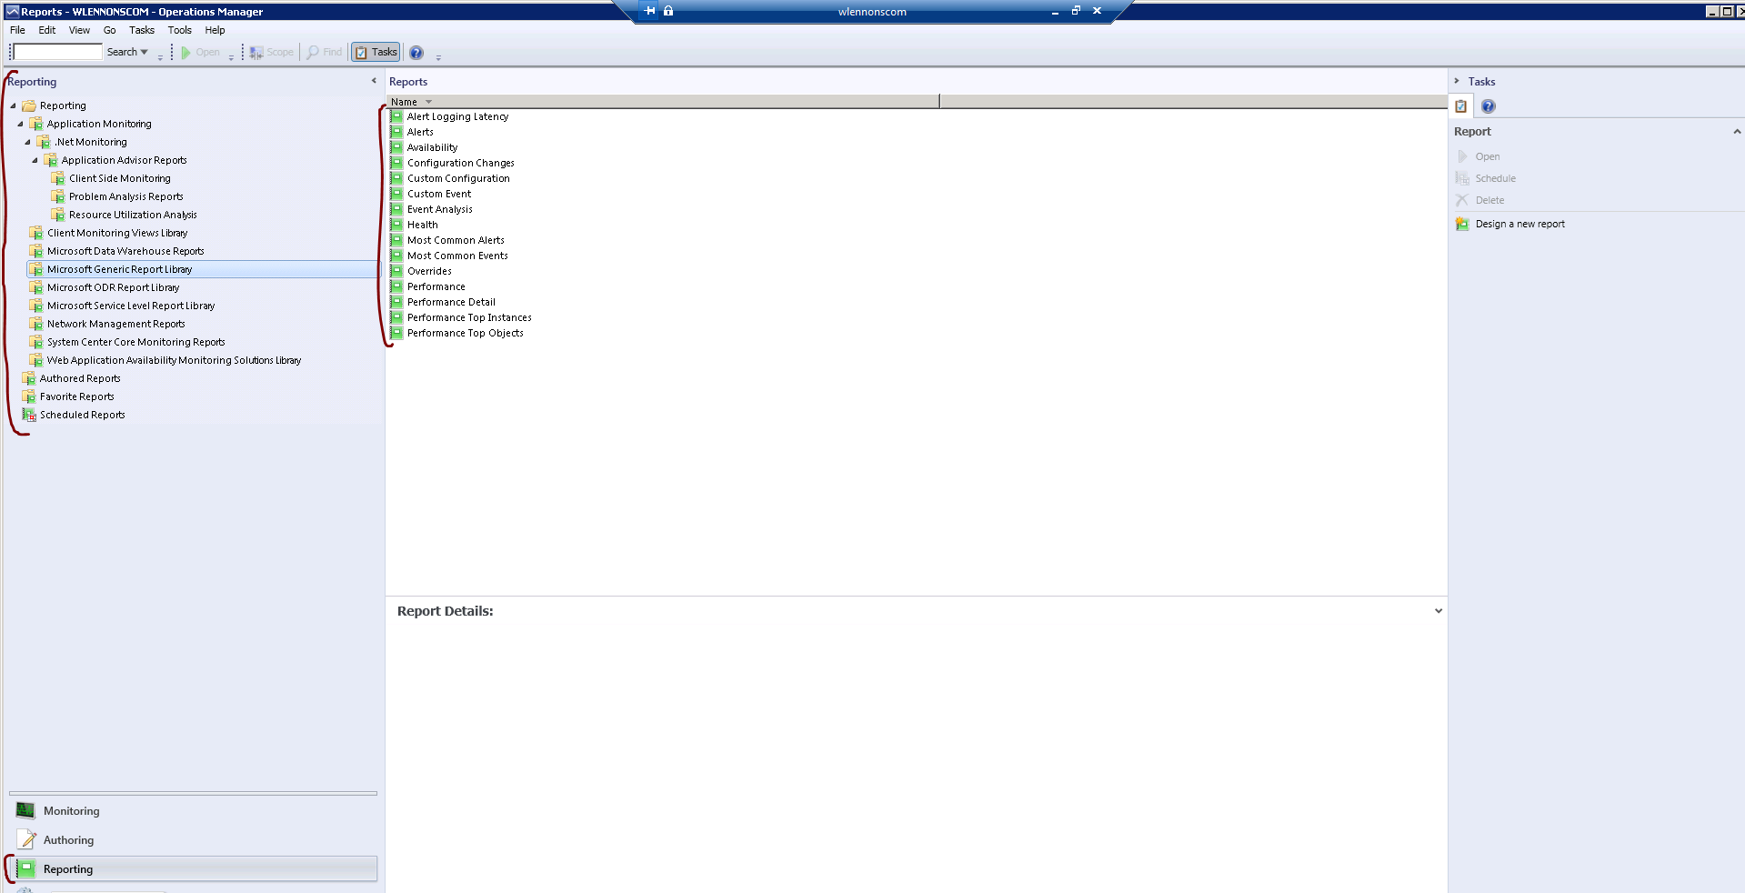
Figure: Operations Manager Standard Reports

A few sample reports are shown below.
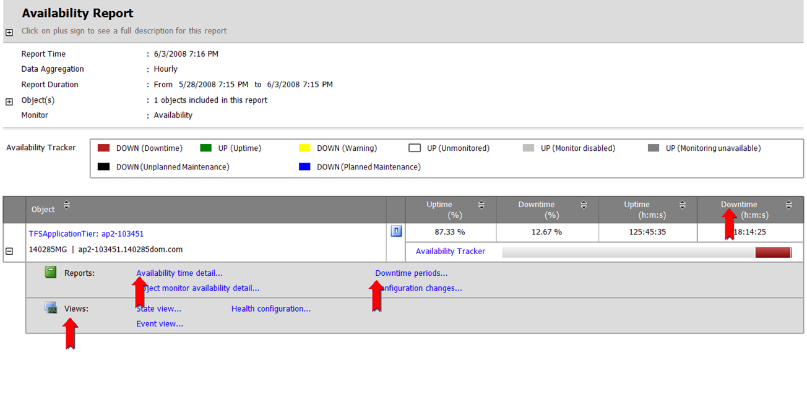
Figure: Availability of Team Foundation Server application tier
The availability report allows drill down detail of downtime. More actions are available by clicking on the actions + plus sign on the report.
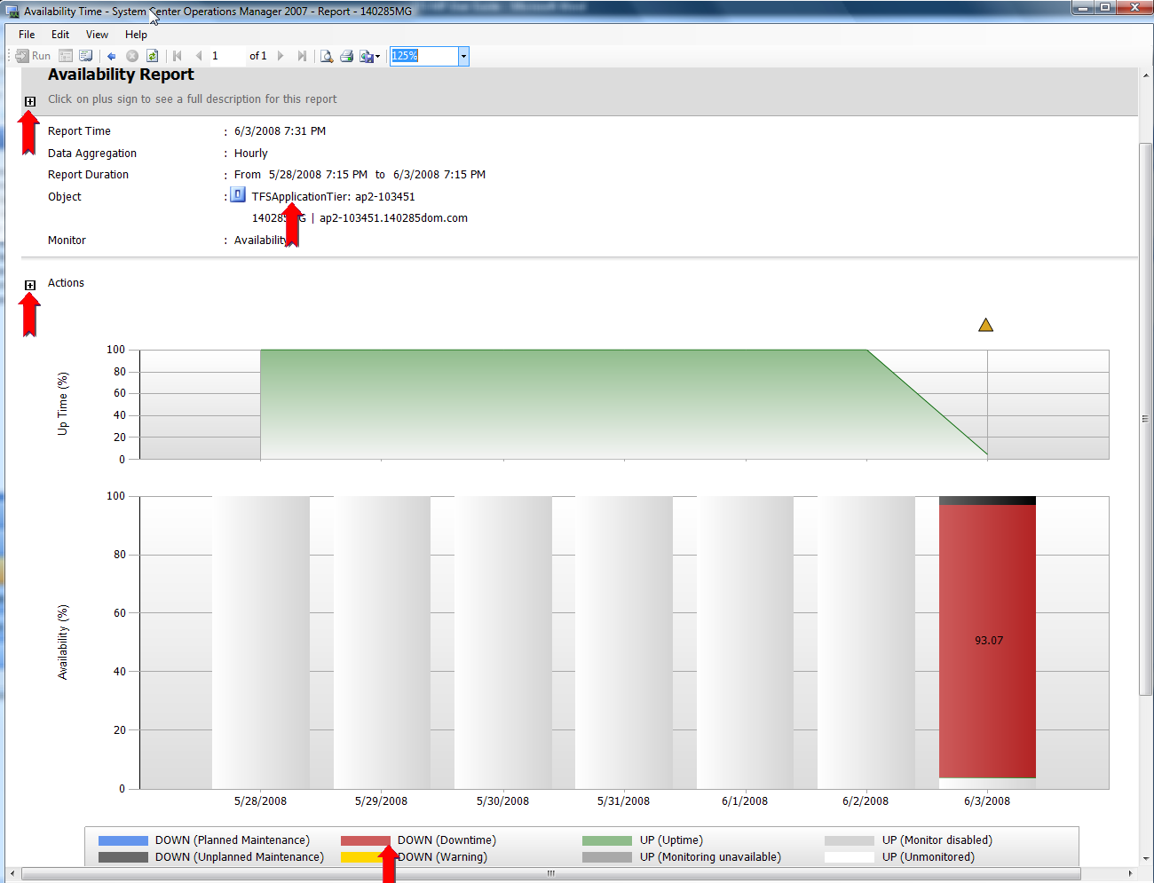
Figure: Drill down into availability time details
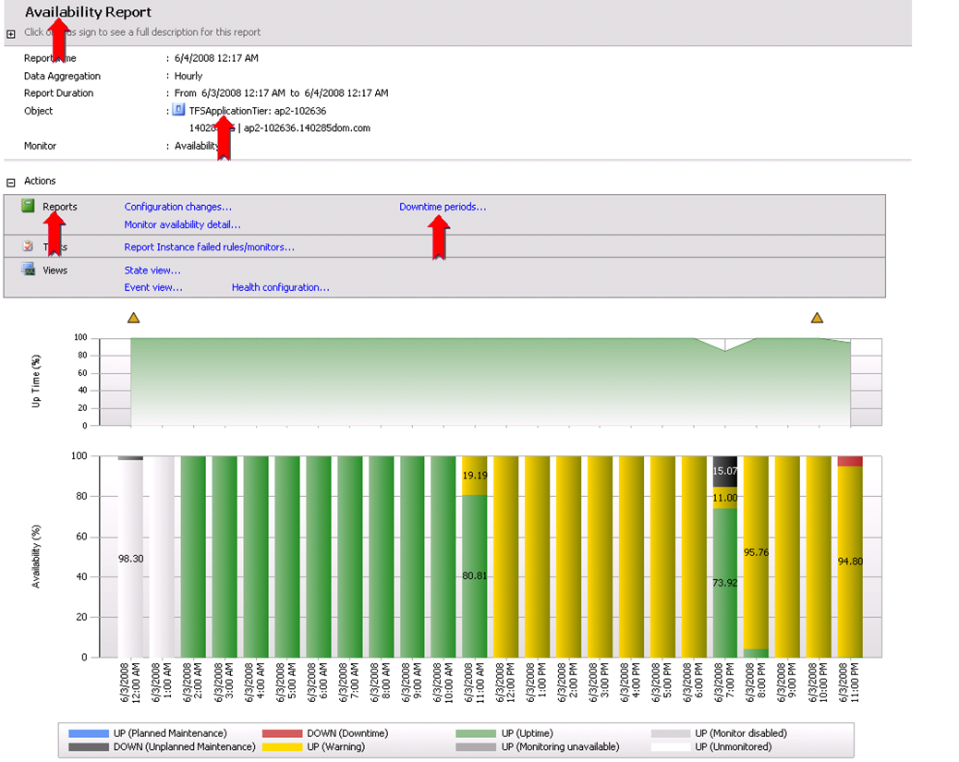

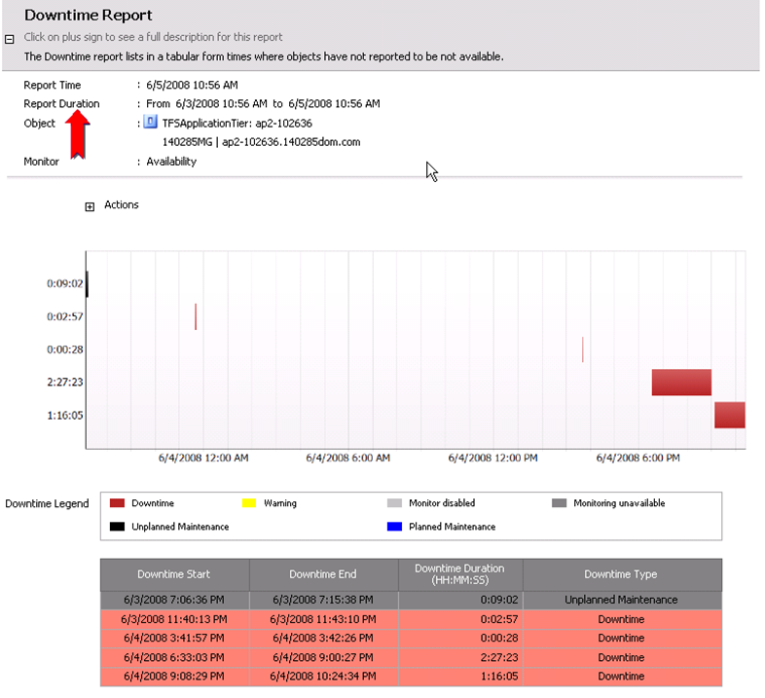
Figure: Downtime periods
The following is an example of an Alert Report
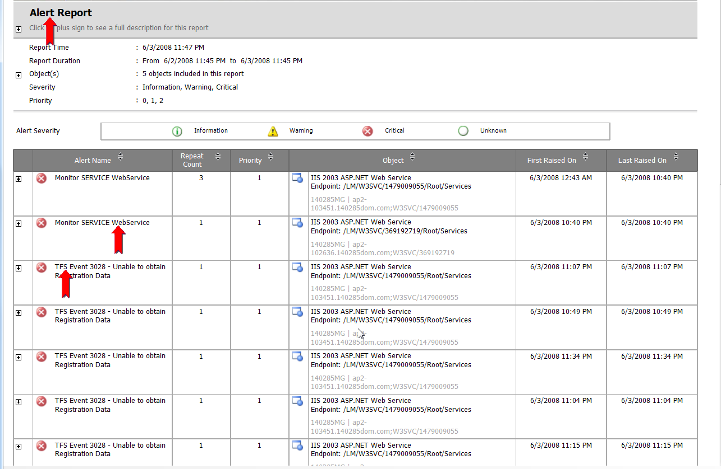
Health – Availability Report

Customizing the Management Pack for your Monitoring Needs
This section provides guidance on tuning this management pack for individual needs. For information on installation and configuration of this management pack, skip to Appendix A.

Create a New Management Pack for Customizations
The Visual Studio Team Foundation Server 2015 Management Pack for System Center is sealed so that you cannot change any of the original settings in the management pack file. However, you can create customizations, such as overrides or new monitoring objects, and save them to a different management pack. By default, Operations Manager saves all customizations to the default management pack. As a best practice, you should instead create a separate management pack for each sealed management pack you want to customize.
Creating a new management pack for storing overrides has the following advantages:
• It simplifies the process of exporting customizations that were created in your test and pre-production environments to your production environment. For example, instead of exporting the default management pack that contains customizations from multiple management packs, you can export just the management pack that contains customizations of a single management pack.
• It allows you to delete the original management pack without first needing to delete the default management pack. A management pack that contains customizations is dependent on the original management pack. This dependency requires you to delete the management pack with customizations before you can delete the original management pack. If all of your customizations are saved to the default management pack, you must delete the default management pack before you can delete an original management pack.
• It is easier to track and update customizations to individual management packs.
For more information about sealed and unsealed management packs, see Management Pack Formats. For more information about management pack customizations and the default management pack, see About Management Packs.
To Create a New Management Pack for Customizations
1. Open the Operations console, and then click the Administration button.
2. Right-click Management Packs, and then click Create New Management Pack.
3. Enter a name (for example, TFS2015 Customizations), and then click Next.
4. Click Create.

Appendix A – Installation on Systems Center Operations Manager

Pre-Requisites
For the Visual Studio Team Foundation Server 2015 Management Pack for System Center to be deployed and used the following prerequisites must be met.
System Center Operations Manager infrastructure must be in place. This means Operations Manager Root Management Server (RMS) must be installed in addition to Agents which must be deployed on each of the servers that need to be monitored. Despite Operations Manager support for agent-less monitoring, the Team Foundation Management Pack does not support agent-less monitoring, and an agent must be installed on all resources which you wish to monitor. Specifically, if you wish to monitor any part of the Team Foundation Server Installation the Application Tier must have an agent installed. You can also optionally install agents on Build Servers, Proxy Servers, etc. If you do monitor a Proxy Server, it is important to also monitor each Team Foundation Server installation that the proxy supports. It is also advised to have an Operator Console for doing administrative tasks
The Team Foundation Server 2015 Management Pack doesn’t require any additional Management Packs that are not part of the standard Systems Center Operations Manager installation.

Steps to Remove Any Previously Installed Versions of the Visual Studio Team Foundation Server 2015 Management Pack for System Center
These steps are only necessary if you previously imported a different version of the Team Foundation Server 2015 Management Pack. If you previously only install Management packs for different version of Team Foundation Server, these steps are not necessary.
Like all Management Packs, you must remove any previous version (please note that Management Packs for different versions of Team Foundation Server are considers separates so you can have the management pack for Team Foundation Server 2015 installed side-by-side with Team Foundation Server 2013). Once the previous version of the management pack has been removed you will need to restart the Health Monitor Windows Service on the server hosting System Center Operations Manager as well as all Server Hosting Team Foundation Server Components.

Steps to Install the Management Pack

Create a Monitoring Account within Team Foundation Server
Prior to installing the Management Pack, a “Run As Account” should be created which has privileges to access Team Foundation Server. This must be a TFS account that is a member of the [Team Foundation]\Team Foundation Administrators group to be able to properly discover and monitor the TFS configuration. It is recommended to create a special account for this in Active Directory and assign it to the required groups within Team Foundation Server. It is not recommended to use an existing Administrator account.

Creating a “Run As Account”
Now go to the System Center Operator Console and open the Administration pane. Expand the Security Node, and then select “Run As Accounts”. Right Click “Run As Accounts” and choose “Create Run As Account” to launch the wizard. This must be a TFS account that is a member of the [Team Foundation]\Team Foundation Administrators group to be able to properly discover and monitor the TFS configuration. The steps to create a “Run As Account” are shown below.
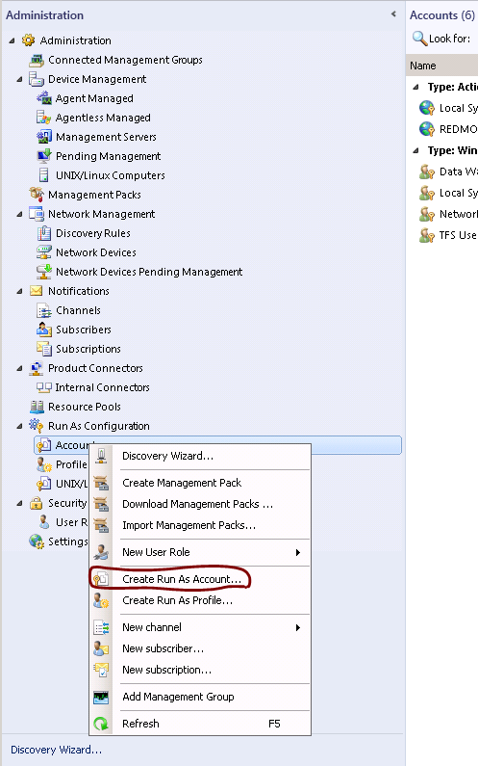

Select “Create Run As Account” and follow the steps in the wizard to create the “Run as Account”.

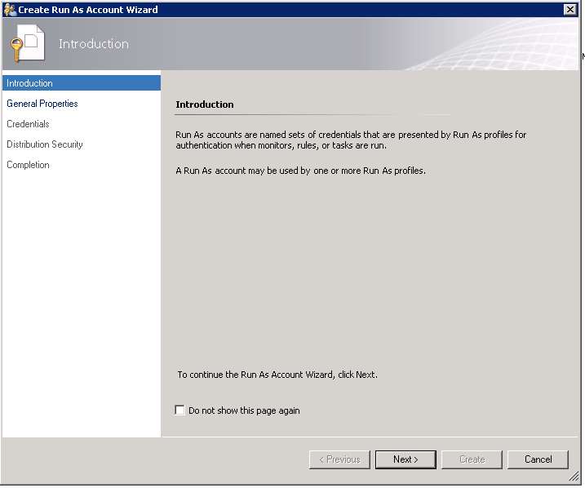
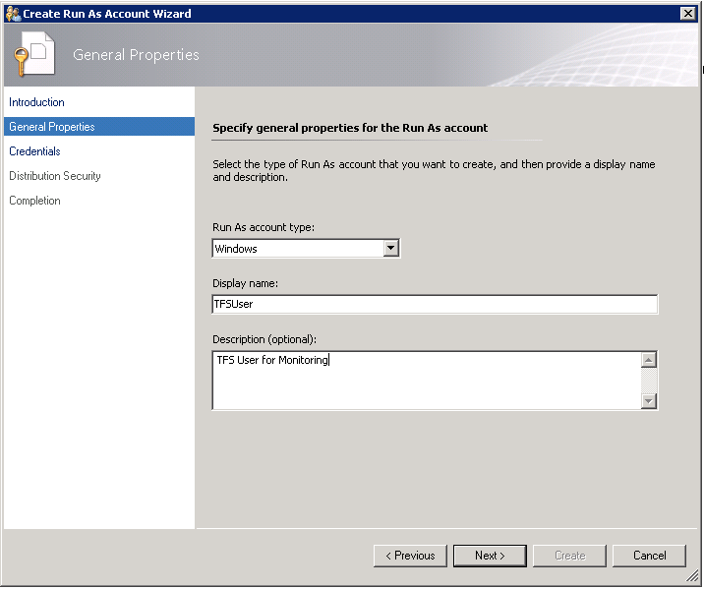
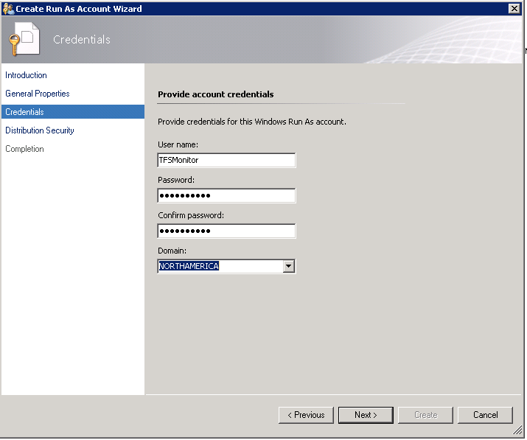

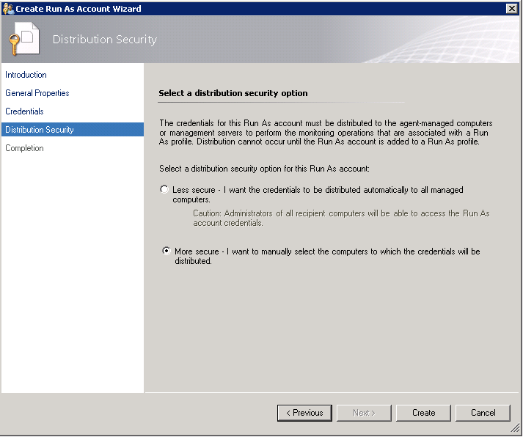
At the end of creating an account, you should see the new account in the “Run As Account” pane of the operator console as shown below.
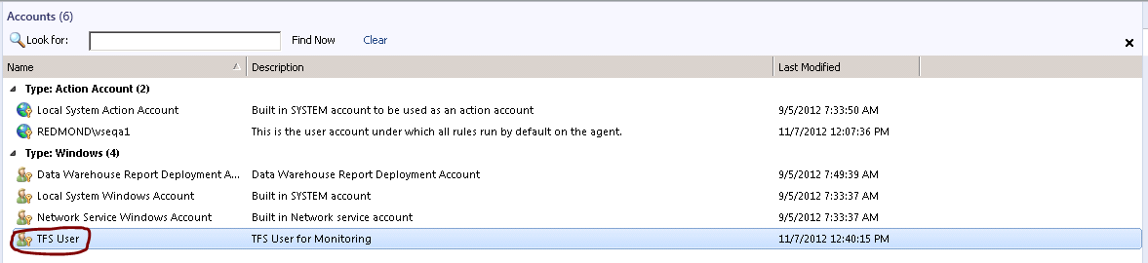

Installing the Visual Studio Team Foundation Server 2015 Management Pack for System Center.
The next step is to install the Management Pack. The install steps are very simple. This can be done by copying the sealed Team Foundation Server Management Pack Bundle into a known location and importing the Team Foundation Server 2015 Management Pack from that location via the “Import Management Packs” option in the Management Console.
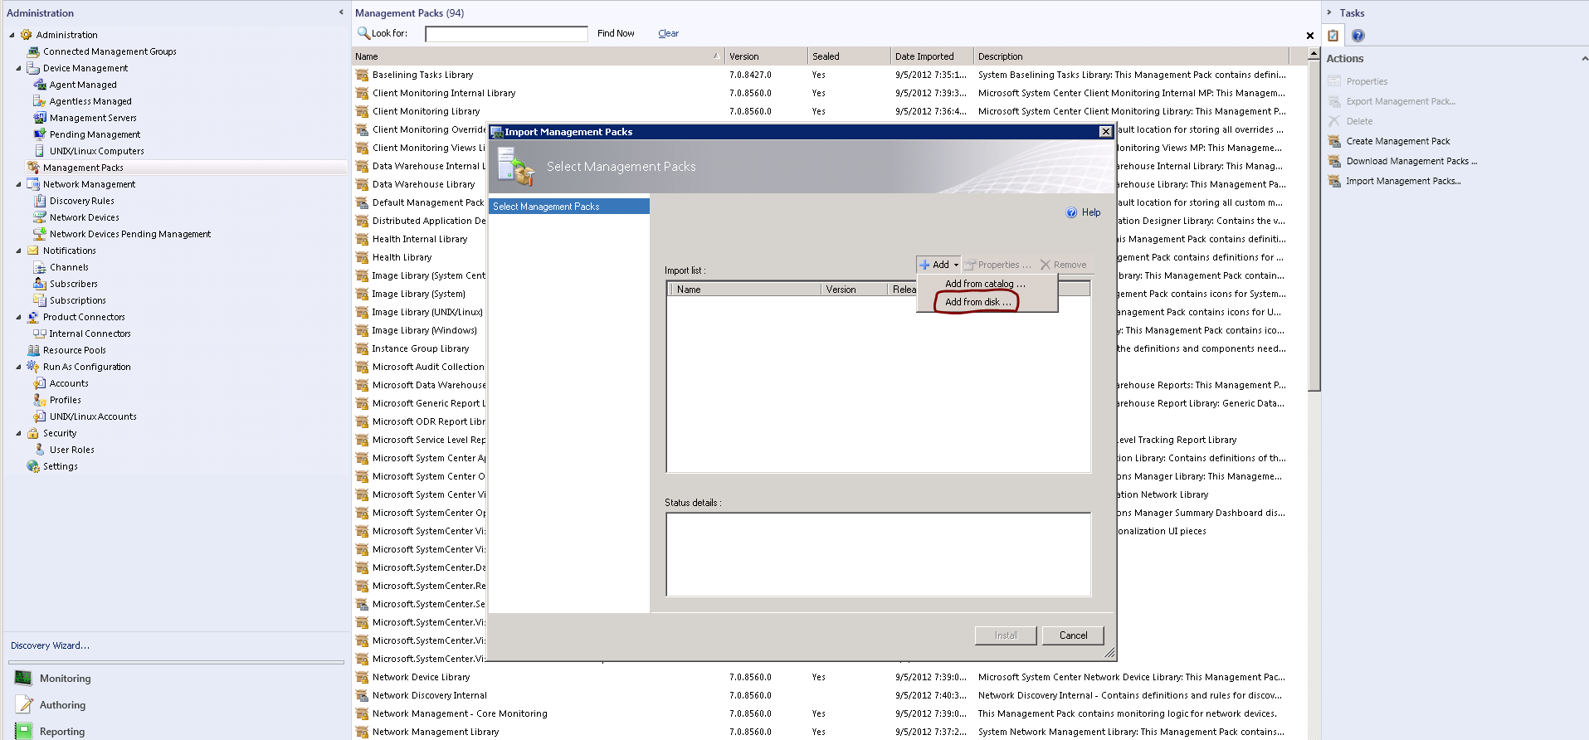

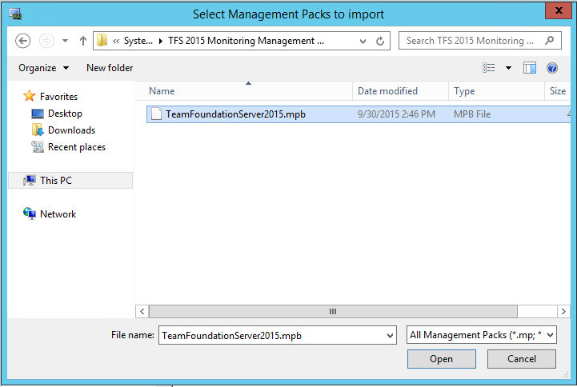
Note: Older versions of the Management Pack used a file with an .mp extension (Management Pack), The 2015 version is an .mpb extension (Management Pack Bundle)

Associate the “Run As Account” to the “TFS 2015 User Profile”
Once the Management Pack has been imported, the next step is to create the association between the “Run As Account” created earlier with the “TFS 2015 User Profile” in the Management Pack. The steps to do this are shown below.
Go to the Administration Pane in the Ops Console and Right Click on the “Run As Profiles” node. You should see the TFS 2015 User Profile in the middle pane as shown below. If it does not appear, Right Click on Run As Profiles and hit “Refresh”.
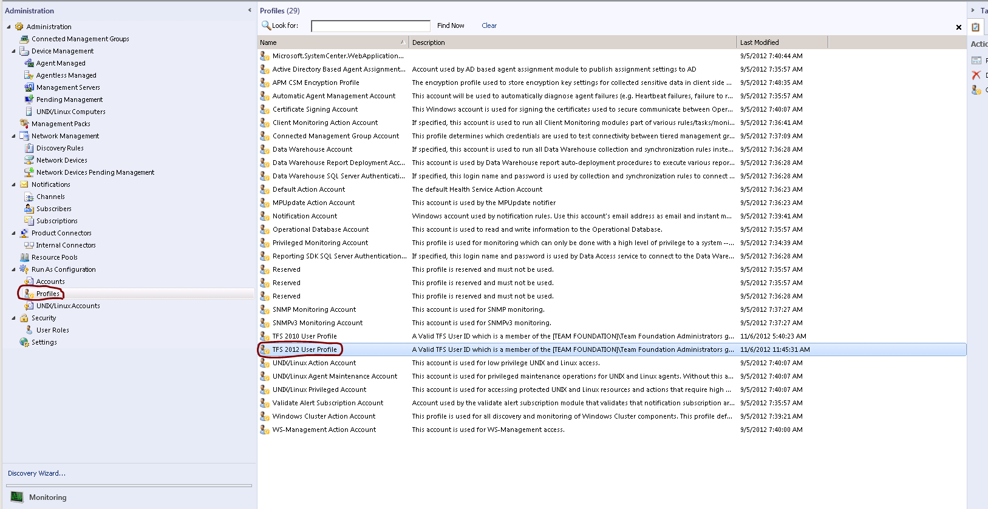

Double click the “TFS 2015 User Profile” Once it is visible. Add the machines on which you want this association to be exercised. This should be all the servers used by Systems Center Operations Manager to discover and monitor your Team Foundation Server Installation and the Application Tier Servers, Build Servers and Proxy Servers. You can determine which hosts to add by looking in Monitoring pane of the Operations Manager console and opening the “TFS Registry Candidate” folder and looking at the TFS Candidate View. This will list all hosts that have been identified to contain registry settings for one or more Team Foundation Server components. If the management pack was recently imported, it may take a few minutes for this list to be populated. If you know the names of the servers hosting your Team Foundation Server components, you can proceed without waiting.
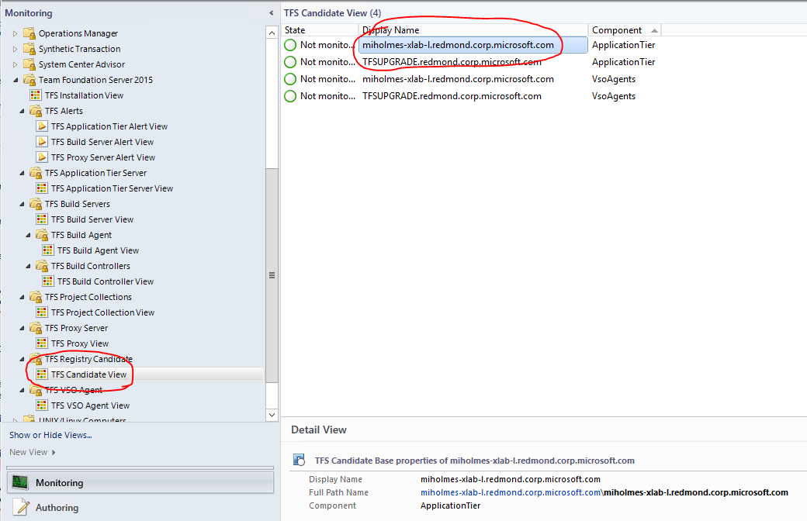
Note: This view will always show these items as “Not Monitored”. Once fully configured the Discovery process will populate the other folders with the detailed items, and those detailed items will be monitored.
Note: Older versions of the Management Pack only required monitoring Application Tier Servers, and their incomplete information could be found in TFS Application Tier Server View.

Make the association for those servers hosting Team Foundation Server components as shown below. Be sure to select “TFSUser” from the Run As Account drop down list.

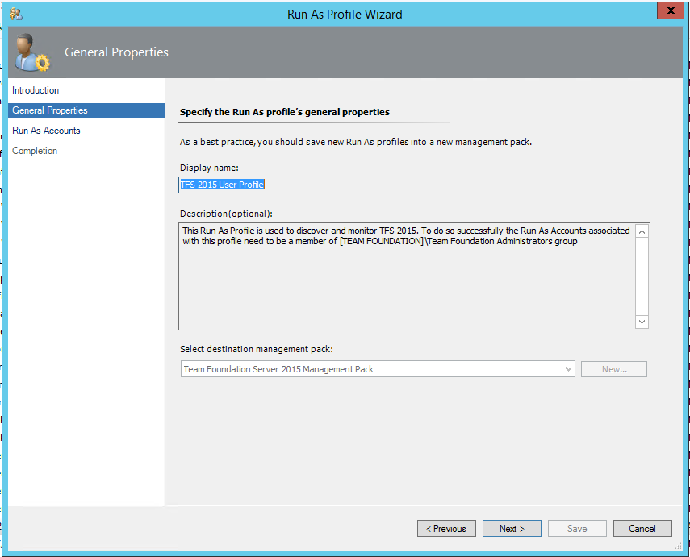

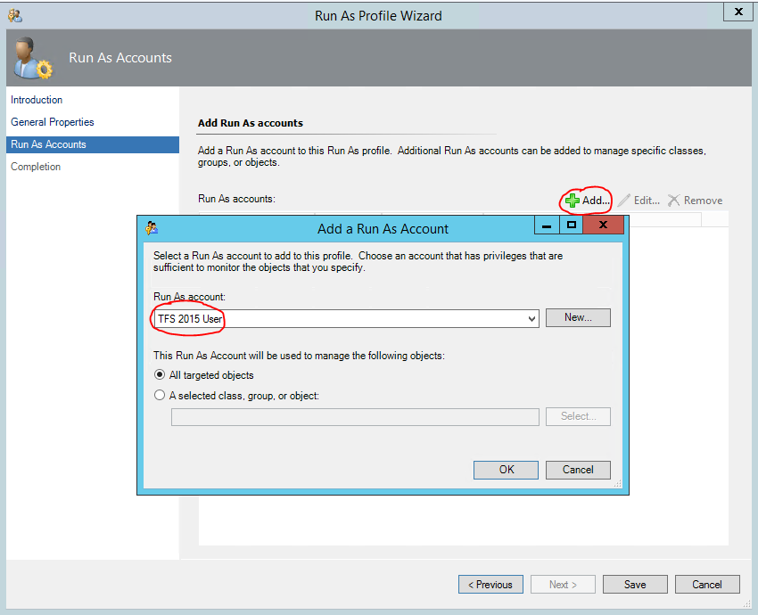

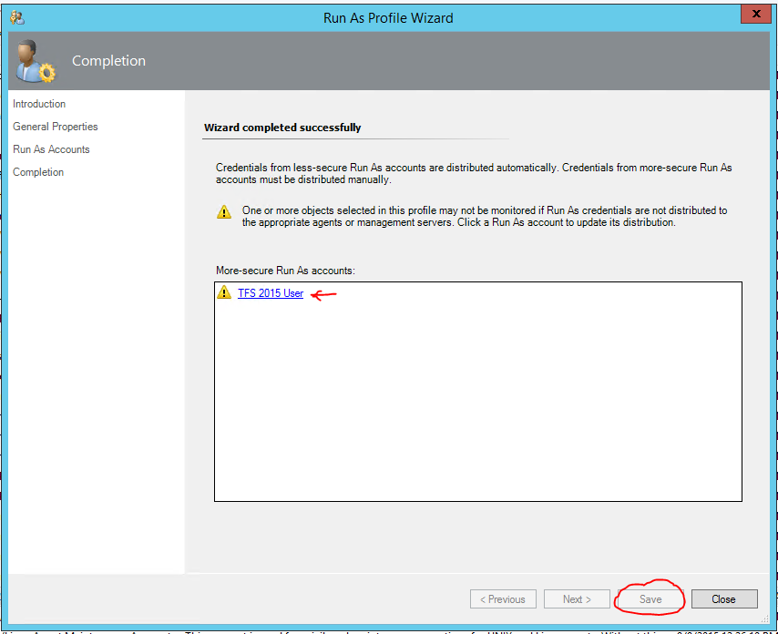

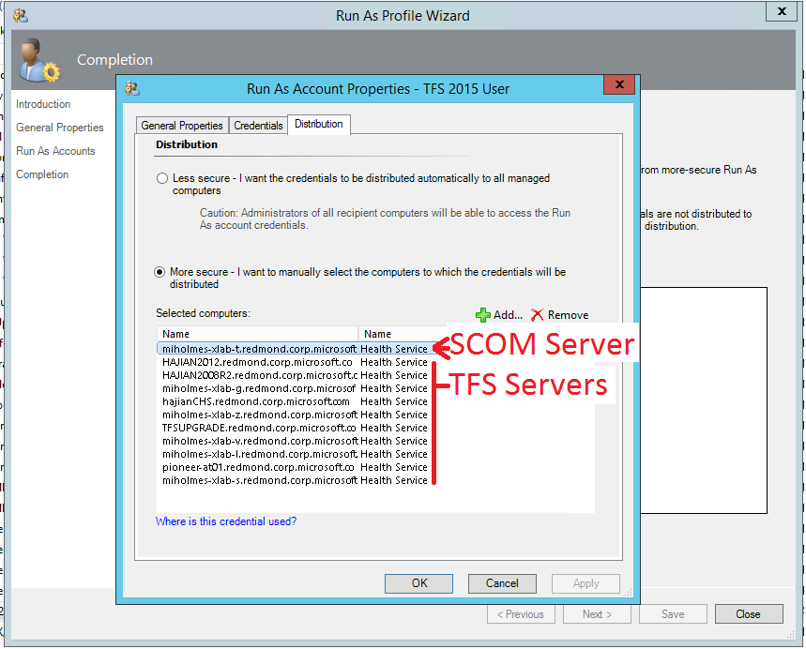

Allow the Application Tier Servers Permissions in Operations Manager.
In order for the discovery of the entire installation to succeed, permissions must be given to the servers that hosts the Team Foundation components to create objects on the behalf of other servers. Once all the servers have been configured as managed assets within Operations manager, you must allow permissions for all servers. To perform this step, go to the Administration view within the Management Console, and select the “Agent Managed” option. A list of servers that have been discovered and are under management is displayed.
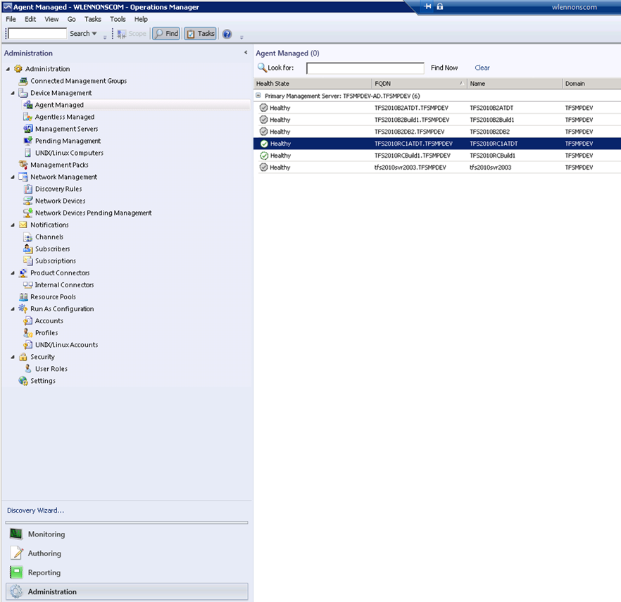
Right-click on each server in the Agent Managed view that hosts part of your Team Foundation Server 2015 Installation and select the Properties entry from the right-click context menu. Within the agent properties dialog, select the “Security” tab and ensure that the check box for “Allow this agent to act as a proxy and discover managed objects on other computers” is selected.

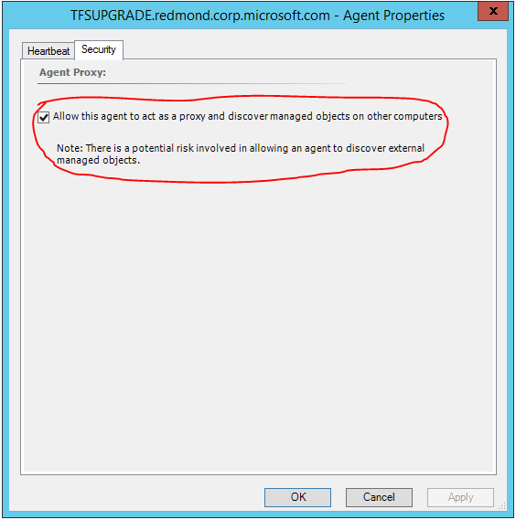
Note: It is not required to monitor All of your Team Foundation Server Installation. For the servers hosting unmonitored parts no health information will be gathered. For all of the server that you wish you monitor you configure them within the Management Console as a Managed Agent, and must allow them to discover other object on other computers as shown above.

Non-Default Port Configuration and SSL Only Bindings
There are two conditions that the discovery cannot detect through the TFS APIs. This is the installation of the TFS web services to a non-default port (not port 8080 for Application Tier Servers, and not 8081 for Proxy Servers), and the use of SSL (HTTPS) only bindings for accessing TFS. If either of these is present in your installation, it will be necessary to modify the management pack with overrides to allow the discovery to complete successfully. This will need to be completed once the management pack has been installed and configured as detailed above. If you need to build overrides for multiple different ports/SSL Only bindings the initial Registry Based discovery within your installation must also be complete. This can be verified by checking the Monitoring tab and check under “TFS Candidate View” for the presence of your Application Tier and Proxy Servers. Once these servers have been found then configure the overrides using the steps as follows:
In the Operations Manager Console, select the Authoring tab and select “Object Discoveries” in the Authoring panel under “Management Pack Objects”.
The console should now display all the object discoveries for all the management packs installed in the main panel. There will likely be many unrelated discoveries displayed from different management packs. Press Ctrl-F and enter “TFS” in the search box.

To set an overrides for Application Tier Servers Discovery under “TFS Application Tier Server” Call “TFS Application Tier Server Discovery Detail”,
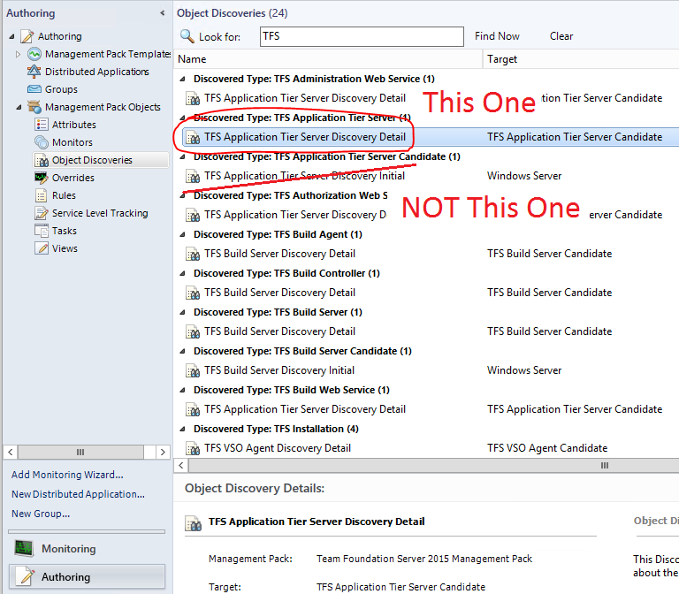
If all of your Application Tiers use the same values for port and SSL Binding, then right click on the discovery and select Overrides -> Override the Object Discovery -> For all objects of class: TFS Application Tier Server Candidate. If instead you need to use different values for different servers instead right click on the discovery and select Overrides -> Override the Object Discovery -> For a specific object of type: TFS Application Tier Server Candidate.

A dialog will appear and you will need to select a TFS Application Tier Candidate that has been discovered.
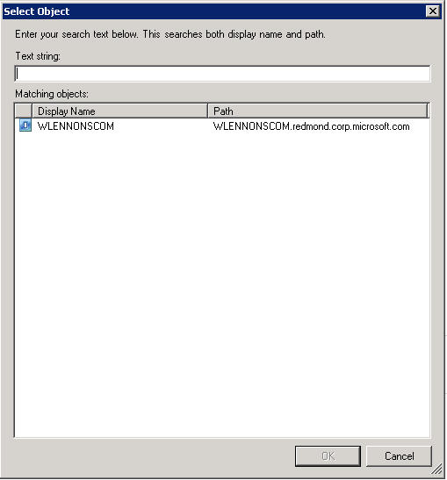
Select the appropriate server and another dialog will appear to allow you to enter the override values.
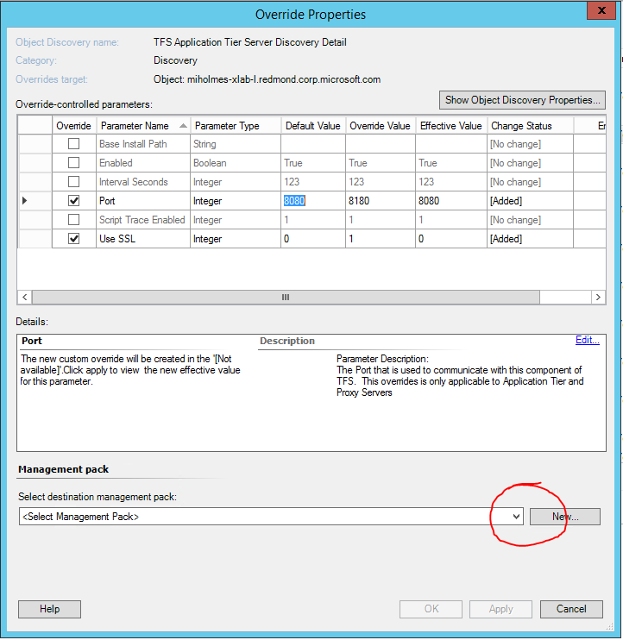
If your installation has a non-default port, select the “Port” checkbox and then enter the port number you have TFS configured to use in the Override Value entry.
If you have set up TFS to only allow SSL (HTTPS) bindings, then select the “Use SSL” checkbox and set the override value to 1.
Make sure to select the Management pack that you created to hold the customization as the destination management pack.
Press Apply to set the values and at this time check to make sure that the proper values are show in the Effective Value column. Press OK to save the overrides.
Repeat this for each Application Tier servers.
Repeat these for any proxy server that either use a non-standard port or require SSL. To do so select “TFS Proxy Discovery Detail” under “Discovery Type TFS Proxy”.

Once this is complete you can return to the Monitoring screen of the Operations Manager Console and wait for the discovery to complete. If after 20 minutes or more the discovery has not completed, then check the troubleshooting section of this guide for further information on how to troubleshoot the issue.

Note: These overrides will be used for all Discoveries that target the specified Application Tier or Proxy server, so it is not necessary to set these overrides under the other Discovery Types

View of the Visual Studio Team Foundation Server 2015 Management Pack for System Center Objects in the Operator Console
After finishing the above mentioned steps, you should be able to see the Management Pack objects in the Operator Console. Go to the Operator Console and click on the Monitoring pane.
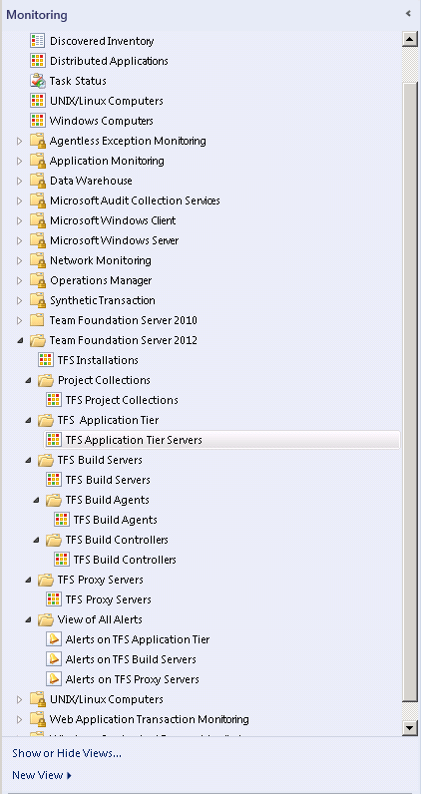
In the details pane, in the middle of the Operator Console, you can see the state views of the various Team Foundation Server Objects by navigating and clicking on them in the left pane. One such state view for the overall top node of the “application tier” is shown below. The figure below shows examples of states for monitored Team Foundation Servers.
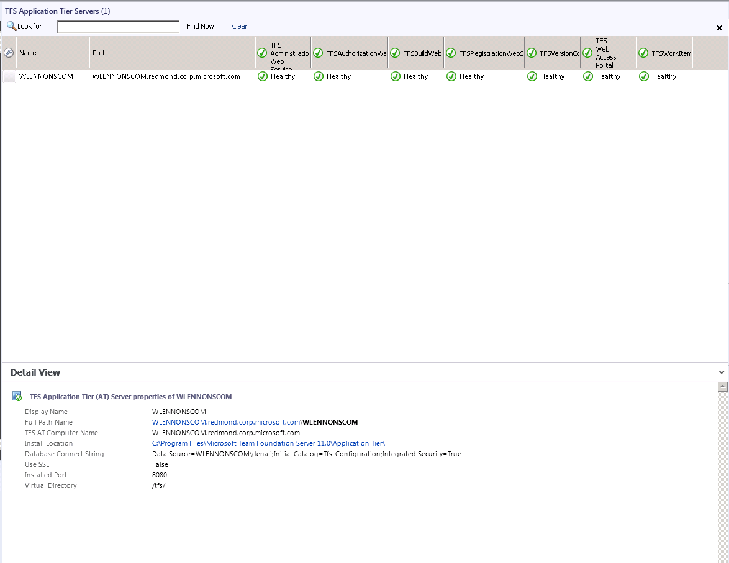

At this point, you are ready to start monitoring Team Foundation Servers in your network.

Appendix B - Known Issues and Troubleshooting

Troubleshooting Incomplete Discovery
The discovery of the TFS installation components is a two-step process. The initial discovery is triggered by registry keys that are set during the installation of the Team Foundation Server product. This will create the initial TFS Candidate objects within the monitoring system. If this has completed, you should be able to locate then in the TFS Candidate View.

If you are unable to locate your server in the TFS Candidate View here are few steps to being troubleshooting
- The Initial discovery is run every 5 minutes by default. Once the discovery has been completed the data needs to be collected by System Center Operations Manager, and then the Operations Manager Console needs to render them. This can take time, so please wait 7-10 minutes for the items to appear in the Operations Manager Console.
- If after that time they still don’t appear start by verifying that the server is listed in the Agent Managed list under the Device Management node of the Administration activity.
  - If it is not there, add it.
  - If it is there but marked unhealthy, right click it, chose Open. From there you can View the Alerts and State View. The right click menu also has option to repair and uninstall the agent
Note: System Center Operations Manager uses a caching system to improve performance. After being uninstalled, reinstalled agents will not behave correctly until the cache is cleared, which can take up to 3 days.
  - If the Agent is healthy then checking the Windows Event log (on both the server being monitored and the server hosting System Center Operation Manger) for problems is the next step. Look in the following locations
    - Application and Services Logs > Operations Manager
    - Custom Views > Administrative Events
- This version of the Management Pack will only monitor servers that are part of a Team Foundation Server 2015 installation.

If you are unable to locate your Team Foundation components (TFS Installations, TFS Application Tier Servers, TFS Build Servers/Agents/Controls, TFS Project Collections, TFS Proxy Server, TFS VSO Agents) first verify that server hosting them is visible if the TFS Candidate view. Until the server is identified as a TFS Candidate, the Detail Discovery will not run for it.

- The Detailed discovery is run every 4 hours on server that have been identified as a TFS Candidate. So it can take some time for the Detail discovery to run and post its results in the Operations Manager Console.
- For the detailed discovery to complete the Run As User and Run As Profile must be set up as specified above.
  - Make sure that the Run As User has been Distributed to the System Center Operations Manager Agent on the server hosting your Team Foundation Component as well as Server hosting Systems Center Operations Manager.
    - Locate your Run As Account (From the Administration activity Run As Configuration > Accounts) and double click on it and apply the changes.
    - On the properties window that opens check Distribution tab and verify that the server is listed there. If not, add it.
  - Make sure that the Run As Profile lists your Run As Account.
    - Locate your Run As Profile (From the Administration activity Run As Configuration > Accounts) and double click on “TFS 2015 User Profile”
    - On the properties window that opens check the Run As Accounts node and ensure that your Run As User is listed. If not, add it and apply the changes.
- For the detailed discovery to compete the System Center Operations Manager Agent for the server hosting your Team Foundation Server component must be marked to allow the agent to act as proxy and discover managed objects on other computers.
  - Locate the server under the Device Management node of the Administration activity and double click on it
  - On the properties window that opens check the Security tab, and verify the “Allow this agent to act as a proxy and discover managed objects on other computers” is checked, and if it is not check it and apply the changes.
- If after validating these items the Team Foundation Server component is still not visible the next step is to check the Windows Event Log (on both the server being monitored and the server hosting System Center Operation Manger) in the following locations:
  - Application and Services Logs > Operations Manager
    - The discovery will use Event ID 9000
      - If the log text indicates that the discovery was unable to communicate with the Team Foundation Server Instance, then verify your Run As Account and Run As Profile Information. Additionally, for Application Tier and Proxy servers make sure that all needed overrides for Port and/or Use SSL are in place. The log text will typically include the URL that the discovery is trying to access. Verify that you can access that URL in your web browser when logged in as the Run As Account.
    - If events with ID 10801 are present it could imply that Agent has not been marked to as “Allow this agent to act as a proxy and discover objects on other computers” or that this change has not been propagated by System Center Operation Management. This is especially true if the text of the event contains “TeamFoundationServer2015”. It may also be necessary to restart the health service on both the System Center Operation Management Server.
    - If events with ID 1102 are present be sure to verify your Run As User and Run As Account information are configured for all of the servers hosing Team Foundation Server Components, as well as the servers hosting System Center Operation Management. Another possible cause is that System Center Operation Management has not propagated it yet.

Troubleshooting Unexpected Health Status
Only after the Discovery completes successfully will the Monitors be run. If you are unable to find the Team Foundation Server components that you expect, check the troubleshooting above for Incomplete discovery. The monitors are run by default every 10 minutes so health changes will not be visible instantly. See the section above called Heath Model for details about how the health state is computed and can be viewed. Drilling down to the most specific node will often indicate which sub component (or components) is unhealthy. If unexpected errors occur while running the Monitoring script, they are recorded to the Windows Event log (Application and Services Logs > Operations Manager) with an Event ID of 19000. If elements are marked as “Not Monitored” make sure to check the Windows Event log (Application and Services Logs > Operations Manager) for events with an ID of 1102. A common cause for that is a problem with your Run As User or Run As Account information. Verify that run as information has been distributed to servers hosting System Center Operation Management.

